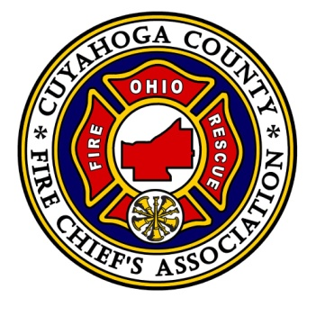
CCFCA Scholarship Guidance
The CCFCA Scholarship program seeks to support and foster higher education in the Cuyahoga County Fire Service by offering assistance and scholarships toward higher fire education while supporting the national professional developmental model.
Scholarship:
The CCFCA will award two scholarships annually helping to support the above mission statement. Each scholarship awarded will be no more than $1500.00 which may be used to help pay for tuition, fees or books. One scholarship will be awarded in May and one in December each year. A scholarship lifetime total maximum award of $3,000 will apply to all applicants.
Application:
Scholarships are available to any member of the Cuyahoga County Fire Service having a Fire Chief who maintains a current membership to the Cuyahoga County Fire Chiefs Association (CCFCA).
Applications and all supporting documents must be submitted electronically to scholarship@ccfca.us before the 15th day of April and the 15th day of November for consideration. The application can be obtained at the CCFCA website.
Essay and Supervisor Recommendation:
The essay and supervisor recommendation is designed to showcase the applicant’s future impact he or she may have on the Cuyahoga County Fire Service. Additionally, essays will be evaluated on how well they adhere to national standards. If the applicant is a Fire Chief his or her recommendation letter shall be from his or her Safety Director, Mayor or City Manager.
Acceptable Programs:
It shall be the sole discretion of the CCFCA Scholarship Committee to determine if the applicant’s degree program and or course meet with the expectations of the scholarship program. Generally, programs taken at an accredited college or university toward an Associate’s degree or higher in Public Safety, EMS, Leadership, Fire Science or Emergency Management will apply.
For further information about the CCFCA Scholarship Program, application or process please contact the Scholarship Committee at scholarship@ccfca.us

